New Delhi, India

October 15, 2024

INCEPTION REPORT

*My Child Helpline*

**Revision History**

|  |  |  |  |
| --- | --- | --- | --- |
| Name | Date | Reasons of Changes | Version |
| iTM | 15 October 2024 | The first draft of the report developed. | v1 |

Chapter 1: Introduction 3

1.1 Purpose 3

1.2 Document Convention 4

Chapter 2: System Features 4

2.1 The System 6

2.1.1 Mobile Application 7

2.1.2 Website 10

2.1.3 Admin Panel 12

Chapter 3: Scope of Work 15

3.1 Inception 15

3.2 Review of Existing System 15

3.3 Mobile Application Updates 15

3.4 Admin Panel Updates 16

3.5 Security, Complaisance and Standards 17

3.6 Testing and Deployment 18

3.7 Documentation and Training 18

3.8 Hosting and Maintenance 18

Chapter 4: Technology Stack 19

Chapter 5: Project Plan 20

Annexure A: Data Structure 21

# Chapter 1: Introduction

## Purpose

The **MyChild Helpline** is an initiative developed in response to the unprecedented mental health challenges faced by children and families during the COVID-19 pandemic. The pandemic led to widespread school closures, restricted access to in-person psychosocial services, and increased stressors within households, significantly impacting children's mental health and wellbeing. Recognizing the urgent need for accessible mental health resources, UNICEF partnered with ChildLine Trinidad and Tobago to launch the My ChildLine App in 2020. This platform provides children and caregivers with direct access to mental health and psychosocial support, offering a variety of child-friendly resources and services.

The primary purpose of the system is to ensure that all children and caregivers across the Eastern Caribbean have access to mental health and psychosocial support tailored to their needs. The mobile app serves as the primary interface for users, while the website complements this by providing additional information and access to relevant resources. The admin panel allows the administrators to manage user interactions, monitor service requests, and analyze data effectively. Together, these components create a support system designed to connect users with essential services, including national toll-free helplines, live chat features for immediate assistance, and a suite of interactive resources.

While the MyChild Helpline system is already developed, there is a need for improvement and enhancement to optimize its functionality and user experience. The purpose of this document is to provide a comprehensive overview of the **MyChild Helpline** developed by UNICEF. This report outlines the inception phase of the project, detailing the objectives, scope of work, and project plan of the system, which includes a mobile application, a website, and an admin panel.

The report will serve as a foundational document to guide the phases of development, ensuring that all stakeholders have a clear understanding of the project’s goals, timelines, and technical requirements.

## Document Convention

This project will be managed using effective project management frameworks and proven methodologies such as AGILE and PRINCE2. This will help to increase the visibility, adaptability, alignment, product quality, business value and customer satisfaction. It will also help to decrease the risk. This first documentation is one of the leading documents to help implement this methodology.

# Chapter 2: System Features

The system has been developed as a comprehensive web-based and mobile application that provides direct access to mental health and psychosocial support (MHPSS) services for children and caregivers. It serves as a central hub for child-friendly resources and services, ensuring accessibility and usability. The system caters to the following stakeholders:

* Children and adolescents
* Parents and caregivers
* Mental health professionals
* Educational institutions
* NGOs and community organizations

Following is the scope of work.

* To review and evaluate the existing system and gather information to refine the system and functional requirements for further development.
* To improve the mobile app's user interface and graphics to ensure usability for all users, including those with disabilities.
* To allow users to monitor their emotional well-being effectively and facilitate robust feedback collection on user satisfaction disaggregated by age, gender, and other demographics.
* To develop an AI-powered assistant or chatbot that can respond to basic inquiries regarding accessing MHPSS support, self-coping techniques, and navigating the app effectively.
* To allow authorized users to add and manage new countries in the system.
* To link user locations to districts instead of pins for accurate geographical representation.
* To implement data security standards for counseling requests and ensure that country admins have access only to their country-specific data.
* Restrict access to servers and manage passwords securely to enhance overall system security.
* To develop detailed user guides and training manuals explaining the features of the system.
* To build the capacity of the stakeholders and other partners to use and manage the system.
* To install, configure and deploy the system on the staging and production server, perform User Acceptance Test (UAT).
* To provide technical support and service to maintain the system.

## The System

The system comprises of the three applications:

* Mobile Application
* Website
* 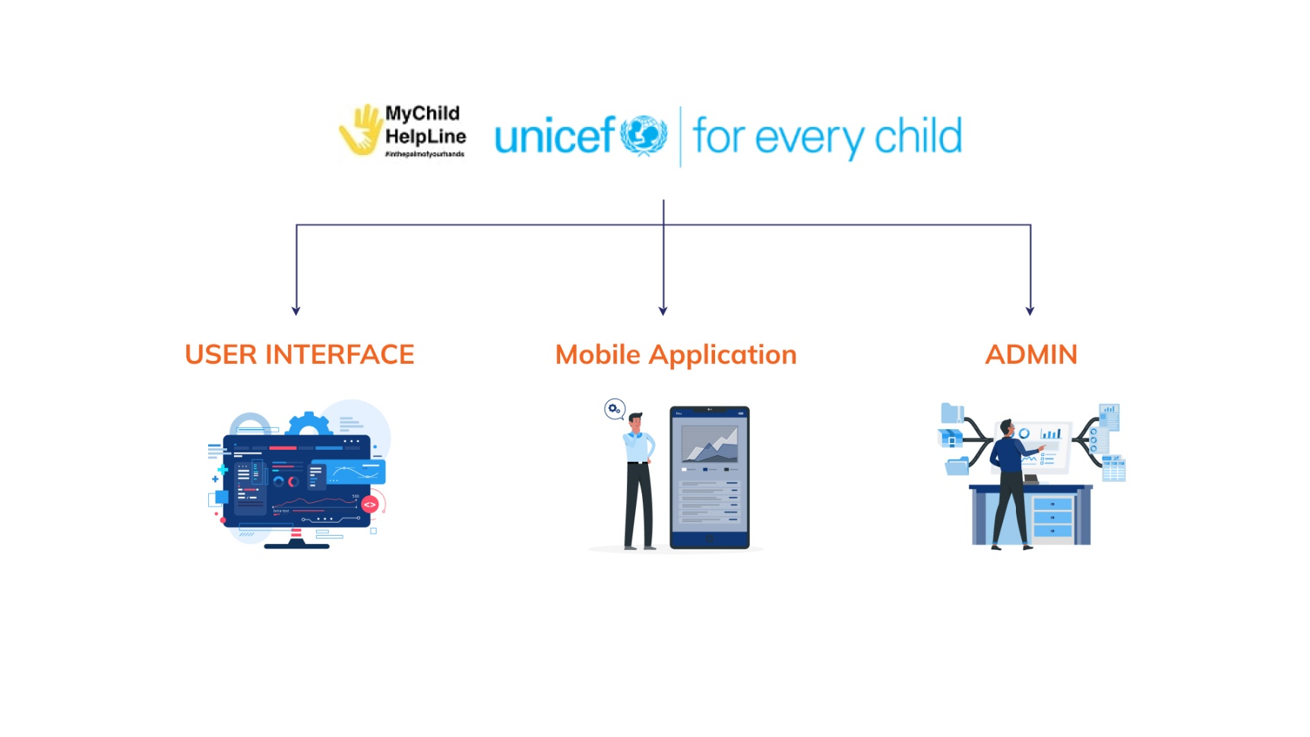Admin Panel

### 2.1.1 Mobile Application

The mobile application for MyChild Helpline is designed for user accessibility and engagement, requiring users to register before gaining access. It comprises of the following modules:

* Register
* Home
  + Call Us
  + Request for Counselling
  + The Parenting Hub
  + Government Services
  + MyChild Helpline
  + UNICEF Eastern Caribbean Areas
* Feeling
  + My Mood Tracker
  + My Diary
  + My Chill Spot
  + My Rights
  + Arcade
* Resources
  + Ambulance Services
  + Health
  + Social Welfare
  + Child Protection
  + Library
  + Police & Related Services
  + Education
* Places
* 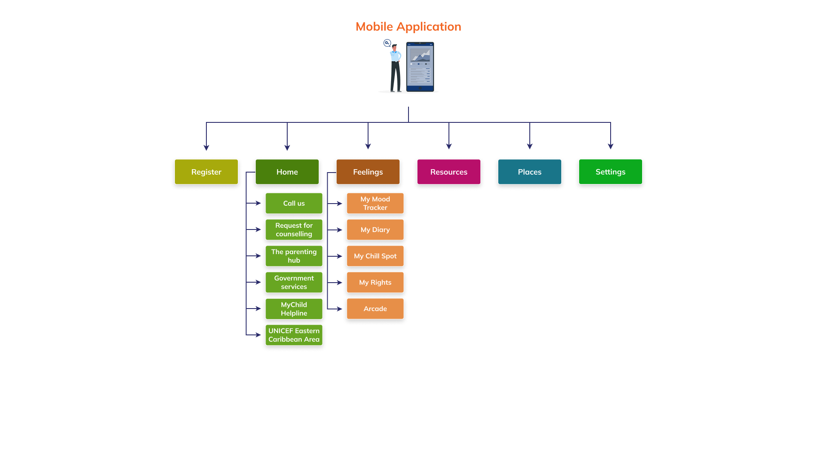Settings

Below is the brief description of the above modules

* The **Register** module allows users to register themselves in the app by creating a secure account and ensure personalized access to the app's features and resources.
* The **Home** module provides quick links to essential services and information, including direct contact options for support, resources related to parenting, and details about UNICEF's initiatives in the Eastern Caribbean.
* The **Feeling** module allows users to explore and manage their emotional well-being effectively. It features interactive tools designed to promote self-reflection and coping strategies. Below are the tools that are available under this module:

1. **My Mood Tracker** allows users to monitor their emotional state.
2. **My Diary** provides a private space for users to write their thoughts and feelings.
3. **My Chill Spot** allows users to engage in calming activities, including guided breathing exercises and "Counting from 10".
4. **My Rights** provides educational content promoting awareness of children's rights.
5. **Arcade** provides a fun and engaging space filled with interactive games that provide entertainment while promoting mental well-being.

* The **Resources module** provides contacts information related to health and safety. It includes access to ambulance services, health resources, and social welfare and child protection services. Additionally, users can find educational materials in the library and information about police and related services.
* The **Places** module allows users to discover various fun, educational, and interesting locations within their registered country. This feature helps users explore local attractions, fostering engagement and learning opportunities in their community.
* The **Settings** module allows users to customize their app experience. Users can change their name, select an avatar, and update their preferred language and registered country. Additionally, the module includes important information about the app, offers a platform for submitting feedback, and outlines the privacy policy. It also features sections on how to use the app and frequently asked questions (FAQs) to enhance user understanding. For those wishing to discontinue their use, the option to delete their account is also available, ensuring users have control over their personal information and app interactions.

### 2.1.2 Website

The website serves as a web-based platform for children, parents, and caregivers to access mental health and psychosocial support resources effectively. This application can be accessed without login and includes the following modules:

* Home
* MyChild Helpline App
* Resources
* FAQs
* How to use the app
* Feedback

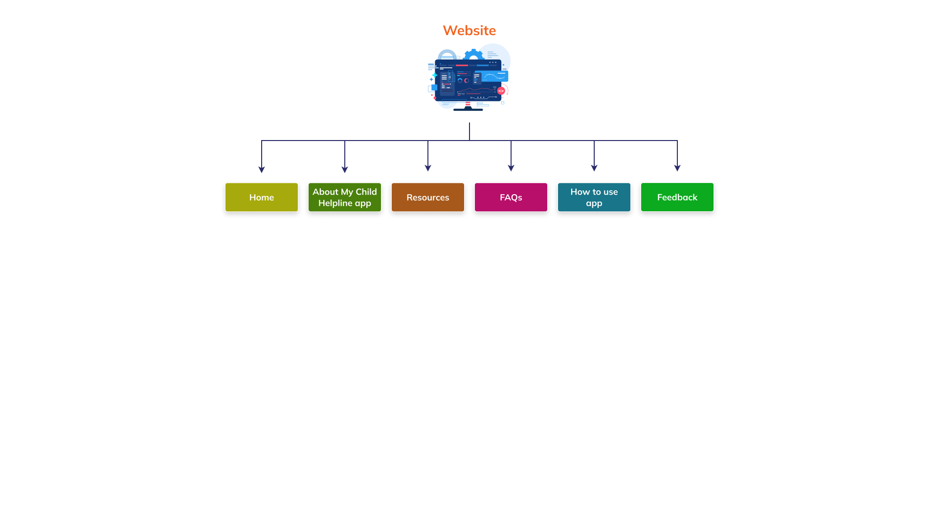Below is the brief description of the above modules:

* The **Home** page serves as the landing page of the website. It provides an introduction and features of the MyChild Helpline application, testimonials, and the partners logos. Download links for the app are available for both Android and iOS devices. Additionally, contact information is provided for users seeking further assistance along with the privacy policy document.
* **MyChild Helpline App** module provides detailed information about the MyChild Helpline mobile application, including its features, benefits, and how it can assist children and caregivers in accessing mental health support and resources.
* **FAQs** module addresses common questions and concerns related to the MyChild Helpline app and mental health services.
* **How to Use the App** module provides step-by-step instructions on how to use and navigate the MyChild Helpline app to ensure users can easily access its features and services.
* **Feedback** module allows users to share their experiences, suggestions, and concerns regarding the app and its services.

### 2.1.3 Admin Panel

The Admin Panel application can be accessed after successful login. It allows to create and manage the underlying data of the system. It will comprise of the following modules:

* Login
* Dashboard
* Users
* Credential
* Chat
* Counselling
* Country
* Mood Trackers
* Category
* Helpline
* Blog
* 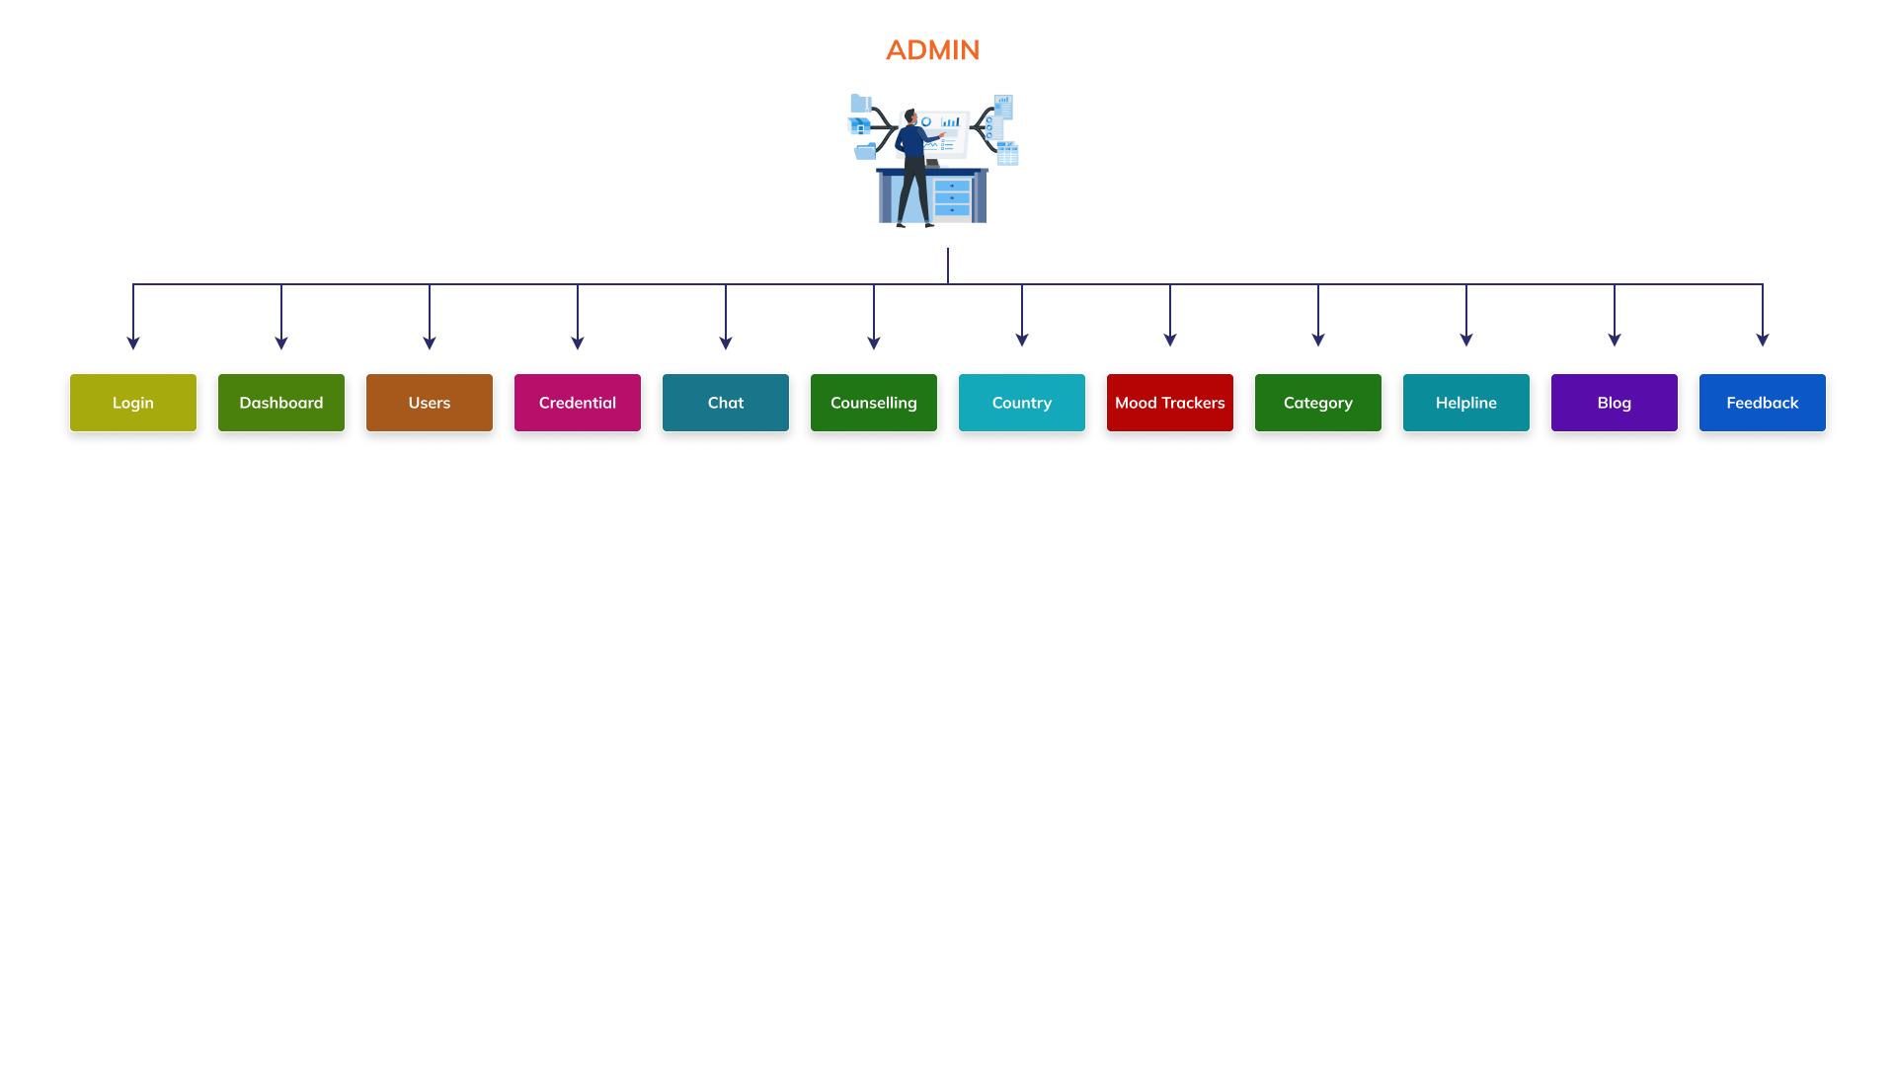Feedback
* The **Login** process helps for user identification, authentication, and authorization. The Login module is the first access point to get into the data manager application. Users with valid credentials will be able to enter their email and password for authentication. There will be CAPTCHA to determine if an online user is really a human and not a bot.
* The **Dashboard** provides a visual representation of key metrics, including the number of feedbacks, blogs, users, and counseling requests. It allows administrators to monitor open and closed cases, user activity, and country-specific data in real-time through interactive charts and summaries.
* The **Users** module enables admins to manage all users registered using the mobile app. Admins can view user details, search specific user, and even edit and delete the required user account. This module also allows admins to track user activity and categorize them based on specific criteria such as age, gender, or country.
* The **Credential** module allows admins to manage system users, including other admins or country-specific administrators. It provides functionality for creating, editing, and deactivating admin accounts, assigning roles, and ensuring that only authorized personnel have access to sensitive system features.
* The **Chat** module facilitates real-time communication between users and admins or counselors. This feature allows for immediate interaction, offering support, guidance, or answers to user queries. Admins can monitor conversations, ensuring that the chat remains professional and helpful.
* The **Counseling** module allows to managing counseling requests submitted through the mobile app. It helps track open and closed cases, monitor response times, and ensure that users receive timely support.
* The **Country** module allows admins to view the existing country list along with the option to delete the specific country.
* The **Mood Tracker** module provides insights into user mood. Admins can view representations of user mood in the table grid along with the option to delete specific record. It supports trend analysis and helps in understanding emotional patterns among users, ensuring tailored interventions when necessary.
* The **Category** module allows admins to add different services within the app, such as feedback categories, blog posts, or helpline services. It streamlines content management, making it easier to filter and present information based on relevant topics for users and also allows to edit and delete a specific category.
* The **Helpline** module manages the various emergency and support services offered through the app. Admins can add or update country-specific helpline numbers, ensuring that users have access to relevant and localized support services when needed.
* The **Blog** module enables admins to create and manage blog posts that can be shared with users through the app. It serves as a platform for providing updates, advice, or useful articles, and can be tailored to address specific concerns such as mental health, parenting, or local events.
* The **Feedback** module allows users to submit feedback on the app’s services, and admins can categorize, track, and respond to these submissions. This module ensures that user feedback is acknowledged and used to improve the system, providing an avenue for users to share suggestions, report issues, or express their satisfaction.

# Chapter 3: Scope of Work

## Inception

This process will involve understanding the existing architecture of the MyChild Helpline system, gather the stakeholder requirements, and defining the scope of work. It will include a comprehensive review of the current system's functionalities. The outcome of this phase will establish a clear and actionable scope of work that will guide the improved design and development of the system. The primary deliverable for this phase will be the Inception Report that will summarize the key findings and outline the proposed updates.

## Review of Existing System

A detailed desk review of the existing system features will be conducted to understand the updates, inputs, processes and outputs of the system. Input collection templates will be developed using google sheets to capture the desk review information. This information will be used to update the functional and structural design of the system as per the scope of work. Google drive storage will be used to store the inputs.Global web development standards and best practices will be used to develop the system.

Online meetings will be conducted to interview the key informants. Requirements will be reviewed and discussed during the meetings. Suggestions and comments will be collected during the meetings for tracking and reporting.

## Mobile Application Updates

A system flow will be designed and developed for the updates required in the mobile application as per the scope. Key updates of the mobile application will include:

* Improve the user interface, graphics, and application logo.
* Implement features to enhance usability and accessibility for individuals with disabilities.
* Integrate the necessary features to align the mobile application with Digital Public Good standards.
* Create a direct link to the MHPSS Chatline for easy access to support resources.
* Develop an AI assistant or chatbot to provide answers to common questions about accessing MHPSS support, self-coping strategies, and app navigation.
* Ensure the application meets UNICEF's app standards
* Implement a notification feature to enable users to receive important alerts and messages.
* Expand and improve the selection of avatars available to users for personalization.

## Admin Panel Updates

A system flow will be designed and developed for the updates required in the admin panel application as per the scope. Key updates of the admin panel application will include:

* Enhancements to make the dashboard module more intuitive and interactive for better user experience.
* Implement filter options to filter data by age, gender, and by country.
* Provide the key metrics such as total users (overall and new within the last 30 days) and detailed counseling request statistics (including open/closed types and response times) to facilitate better decision-making.
* Implement security measures that restrict country-specific data access for country admins, while allowing UNICEF to view aggregated data with advanced filtering options.
* Develop feature to that capture and analyze mood tracking data over time.
* Implement automatic email notifications to new country admins upon approval, providing access details such as username and password.
* Feature to remove or deactivate the chat.
* Restrict access of country admins to view only requests from their own countries.
* Develop a case management system that includes features to add new case, update its status and archive cases closed before more than 1 month.
* Incorporate graphics that display selected moods based on location, country, and disaggregated by sex over time.
* Categorize feedback (app issues, service feedback, recommendations), implementing data safety standards and avoiding spam. The system should automatically respond with a thank you upon receipt of feedback, which could also be country-specific.

## Security, Complaisance and Standards

The scope of work for security updates will include the following updates:

* Ensure the application aligns with ISO/IEC 25010 standards to enhance system quality across various attributes, including performance and security.
* Restrict server access by closing SSH connections that are currently exposed to the internet, thereby reducing the risk of unauthorized access.
* Change all passwords and securely share the new credentials using an encrypted file, such as Keepass, to safeguard sensitive information.
* Remove any instances of clear text passwords within the application.
* Document the application architecture thoroughly to provide an outline of system components and data flows.

## Testing and Deployment

The development team will set up, configure, and install the mobile application and admin panel on the production server. This process will also include configuring the hosting environment and ensuring that all necessary dependencies are in place. A User Acceptance Test (UAT) will be conducted on the production server to ensure that the application meets user expectations and requirements. Any issues identified during UAT will be documented, tracked, and addressed accordingly. Following the resolution of these issues, recommendations will be provided to facilitate a smooth launch of the MyChild Helpline system. Additionally, the technical documentation will be updated to reflect any changes made during the development and UAT phases.

## Documentation and Training

Technical guidelines on deployment and maintenance, training manuals and user guides will be developed and submitted for approval. The guides will include the step-by-step process of deployment of the system in the production environment on a web server. User guides will be developed to help to follow the steps, learn and understand the features of the system. The user manuals will be developed to provide detailed explanation on the steps to use the system. Training materials will be developed including templates for participants list, training agenda, training presentations and hands-on exercises. Training sessions will be conducted for end-users, administrators, and support staff on how to use and manage the system.

## Hosting and Maintenance

Post-implementation review will be conducted to assess the success of the development phase, identify lessons learned, and plan for future improvements. Monitoring and troubleshoot the functioning of the system will be provided after it goes live to deal with any technical glitches and related issues that may impact on the functioning thereof and fix all glitches and errors.

# Chapter 4: Technology Stack

The updates will be developed using the following environment and tools. See **Annexure E: Software Architecture.**

**Web Applications**

Operating Tool Ubuntu v20.04

Front-end Language JavaScript vES2015, HTML v5.0, CSS v3.0, React-native V-0.64.1 (Mobile Application), Node - 16.3.0 (Mobile Application)

Visualization Library ECharts v5.5.1

Front-end Framework AngularJS v16

Back-end Language Node.js v18, PHP v7.4

Back-end Framework Express v4.21.1, Laravel v11

Database Tool MySQL v8.1

Server Type Apache v2.4*, Docker v20.10.7, Docker composer v1.27.0

# Chapter 5: Project Plan

|  |  |  |  |
| --- | --- | --- | --- |
| # | Tasks | Deliverables | Date in TOR |
| 1 | Project initiation and information gathering |  |  |
| 2 | System Requirements Specifications |  |  |
| 3 | Design wireframes and development of system flow |  |  |
| 4 | System deployed, tested and hosted |  |  |
| 5 | Documentation and Training |  |  |

# Annexure A: Data Structure

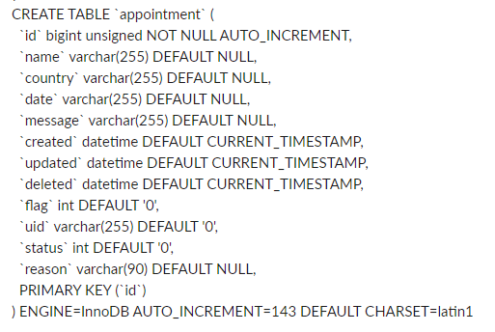**Announcement**

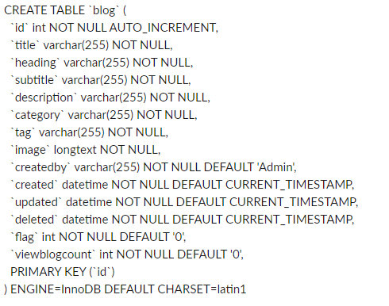**Blog**

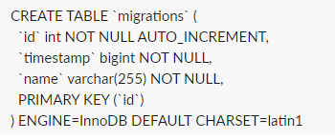**Migration**

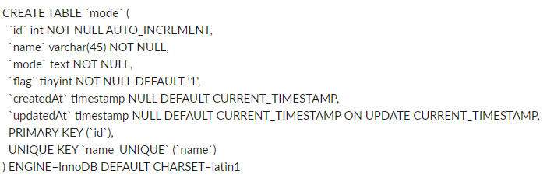**Mood**

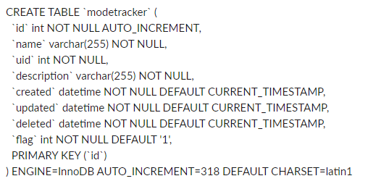**Mood Tracker**

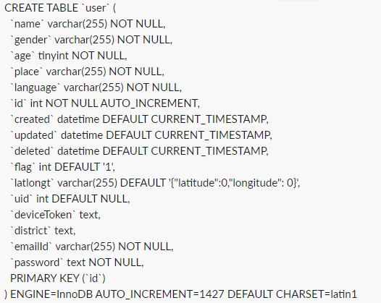**User**

--- End of the Document ----